**Preliminary TASK report**

|  | Task Description | Hours Estimated | Deliverables | Status |
| --- | --- | --- | --- | --- |
| 1 | Finalise the Database to work on and test connectivity with Oracle. | 2 | Database.java | Submitted |
| 2 | Formulation of DDL Queries  -> Create table queries | 9 | COMBINED_DDL.SQL which contains Triggers, tables, constraints, procedures | Submitted |
| 3 | Formulation of SQL Constraints and Rules    -> Modify the Create table query to add the cardinality and participation constraints.  -> Access modifier constraints | 9 |  | Submitted |
| 5 | Creation of Dummy Data for Insertion and testing | 2 | Queries for populating the tables with the sample data is in DataInsert.sql. | Submitted |
| 6 | Formation of Test queries | 4 |  | Submitted. |
| 9 | Creation of JAVA console application | 2 |  | Submitted |
| 10 | Application flow diagram | 1 |  | Provided to us |
| 11 | Final Report | 2 |  | Submitted |

**FINAL DATABASE MODEL (**Submitted as Document 1B)

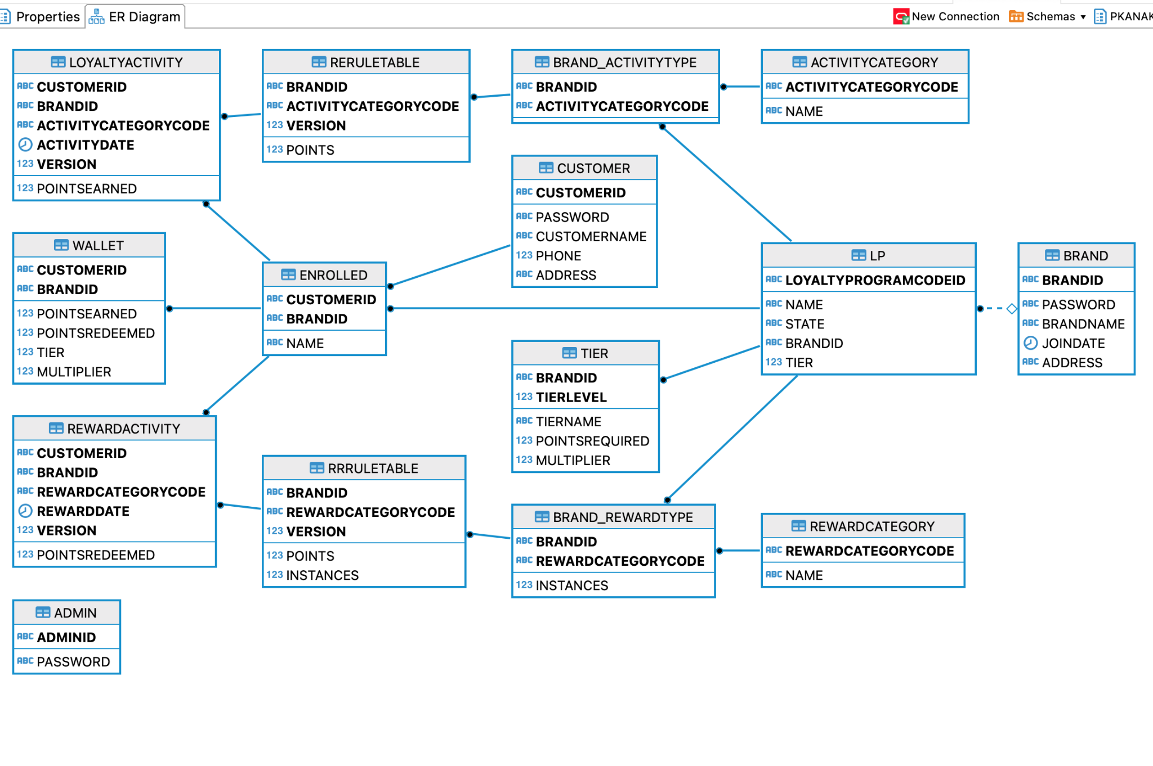

**FINAL ER MODEL (**Submitted as Document 1A)

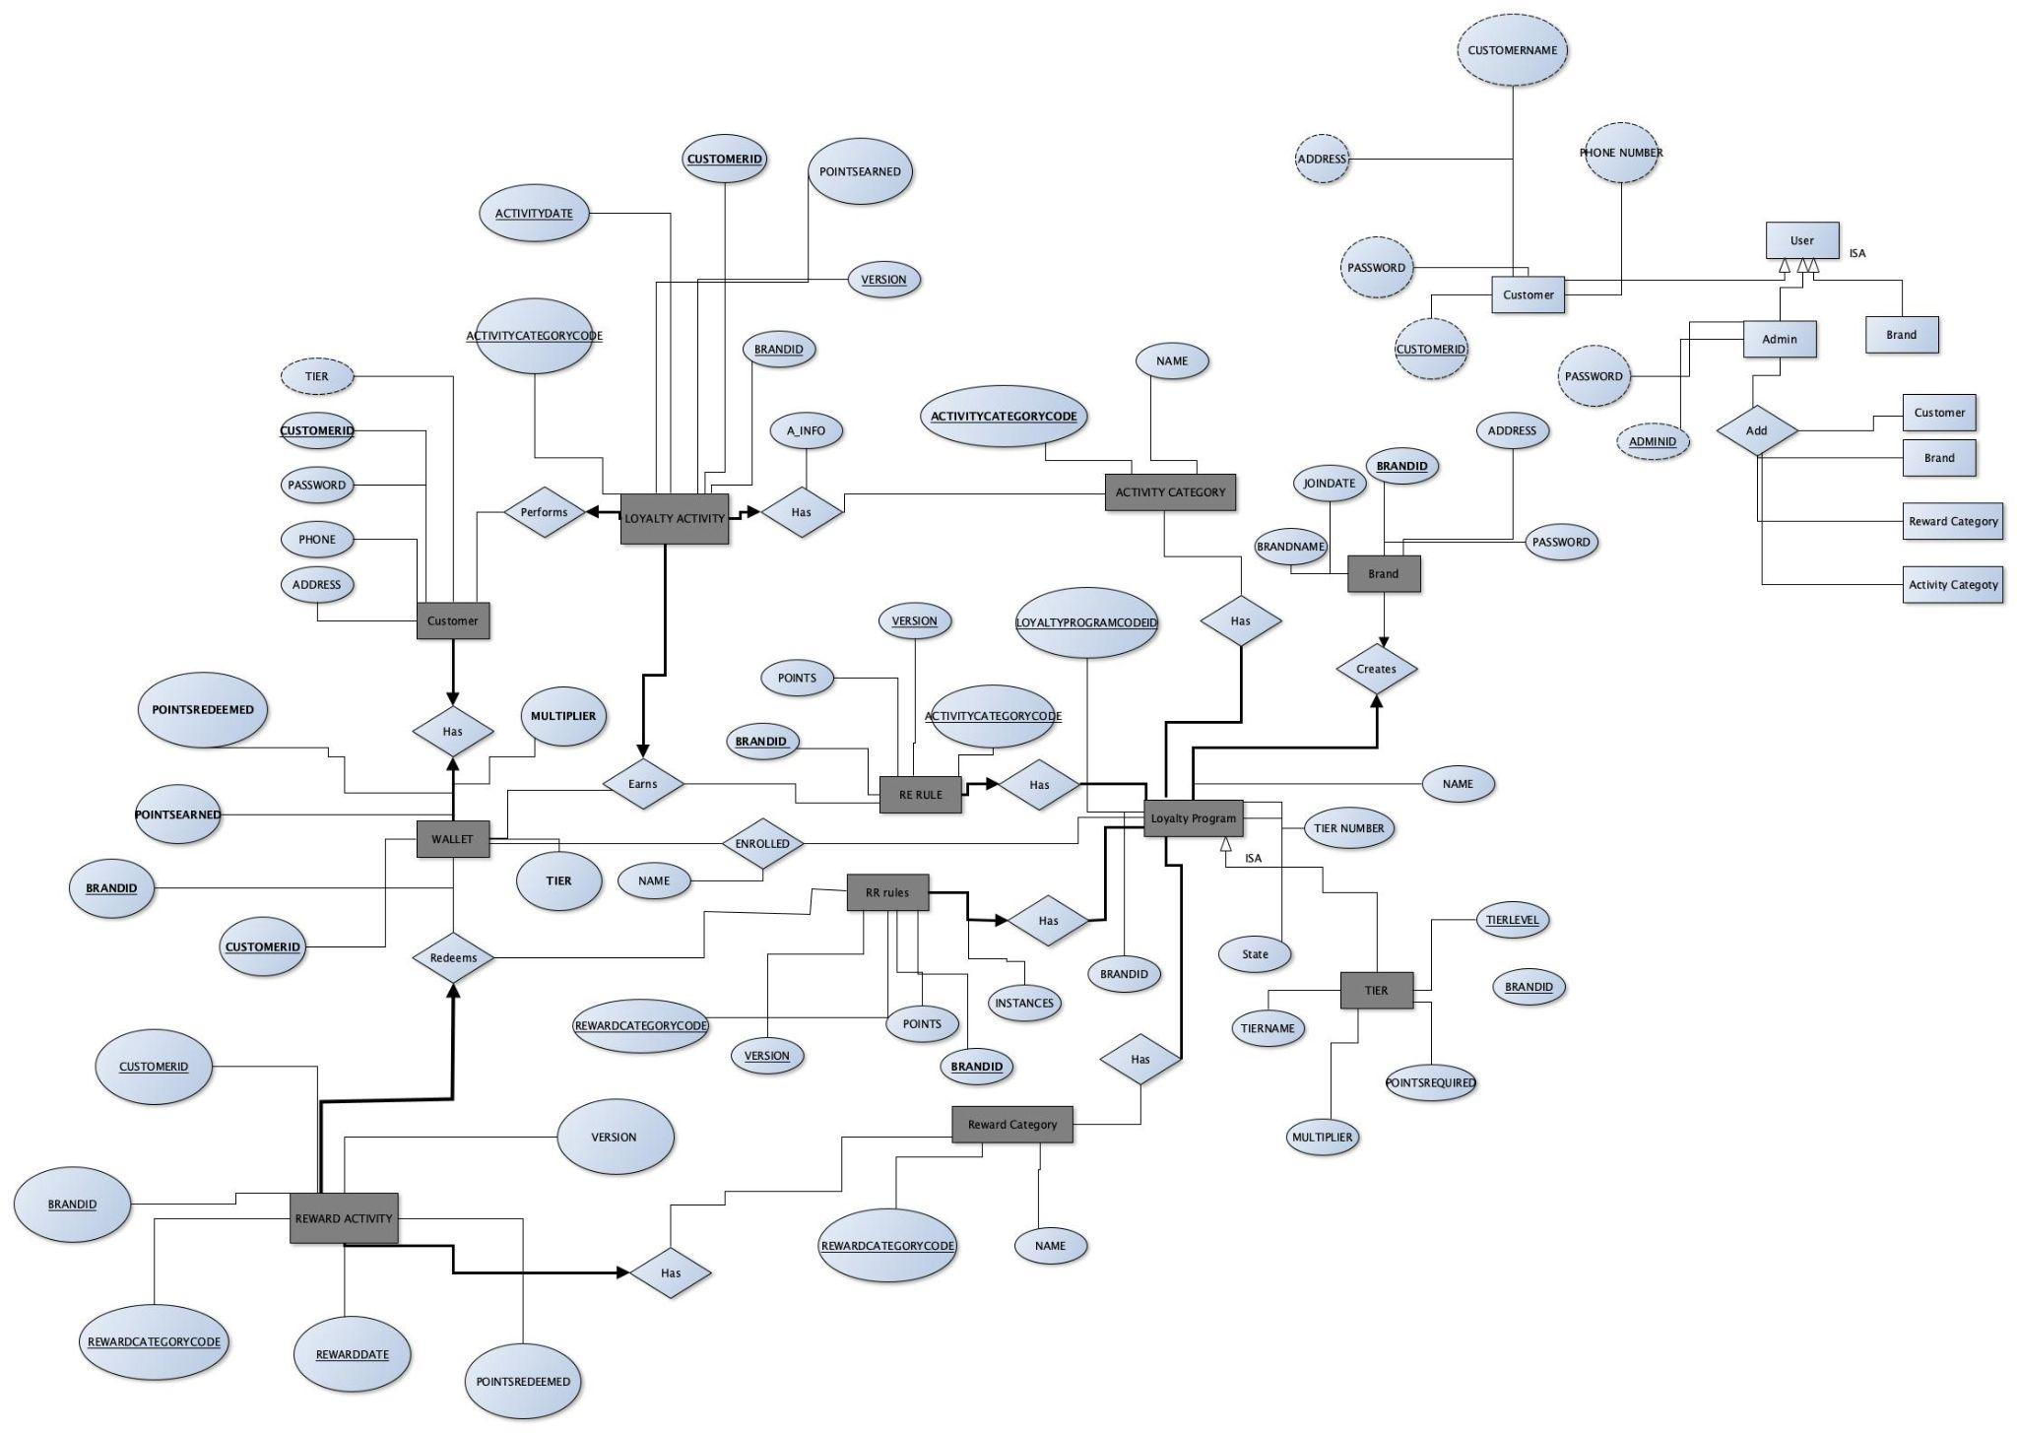

**Initially Submitted ER Model (Submitted Initially)**

